Internship Task Report
Intern Name: Prachita Sudarshan Gajbhiye
Internship Program: Frontend Development Internship
Company Name: Cognifyz Technologies
Internship Level: Level 1 & Level 2
Task(s) Completed: All tasks from Level 1 and Level 2
Submission Date: 18/02/2025

1. Introduction
This document contains the completed tasks for Level 1 and Level 2 of the Web Development Internship. The tasks involve front-end development using HTML, CSS, JavaScript, and front-end frameworks like Bulma and Bootstrap.

2. Task Details

Level 1 - Task 1: HTML/CSS
- Objective:
  - Create a simple webpage with a heading, paragraph, and image using HTML and CSS.
  - Build a basic form with a single input field and a submit button using HTML and CSS.
  - Design and code a simple navigation menu with three links using HTML and CSS.
Implementation Details:
- The webpage is structured using semantic HTML elements.
- The CSS file includes styles for the body, navigation menu, and form to ensure a clean layout.
- The navigation menu is implemented using a <nav> element with a ul list for links.
- A responsive design approach is used to adjust layouts for different screen sizes.

- Output Description & Screenshot:
  - The webpage includes a structured heading, paragraph, and an image.
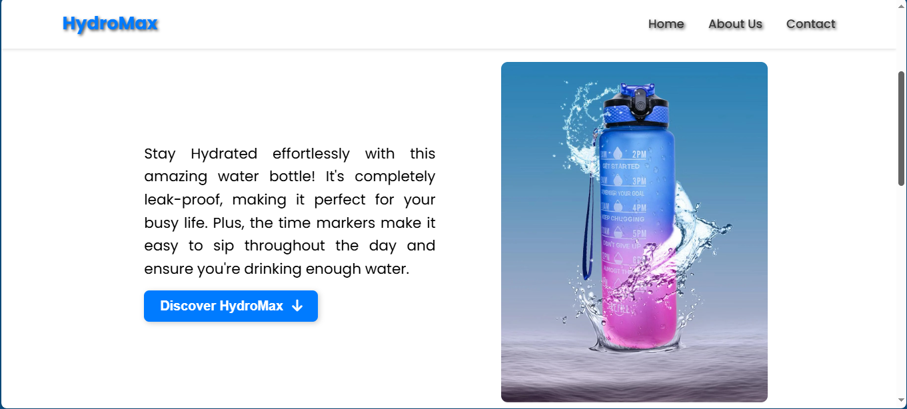
A simple form with an input field and a submit button is present.
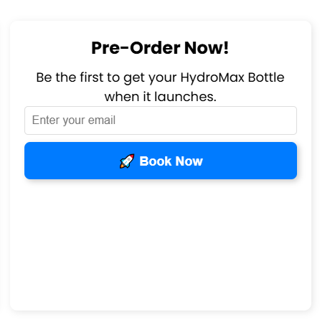
  - The navigation menu contains three functional links and is styled for clarity.

  - The page layout is visually appealing and responsive.

Level 1 - Task 2: JavaScript
- Objective:
  - Develop a basic button that changes its color when clicked using JavaScript.
  - Create an alert box that displays a greeting message based on the current time using JavaScript.
  - Build a basic calculator that adds two numbers together and displays the result using JavaScript.
Implementation Details:
- The color-changing button is implemented using an array of predefined colors and event listeners.
- A greeting message dynamically updates based on the current system time using Date methods.
- The calculator accepts two numeric inputs, validates them, and displays the sum.

- Output Description & Screenshot:
  - The button successfully changes color when clicked.
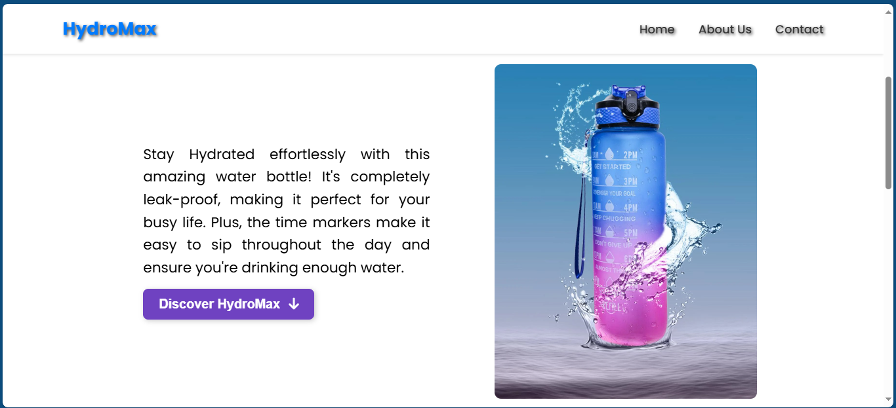
  - The alert box displays an appropriate greeting based on the time of day.
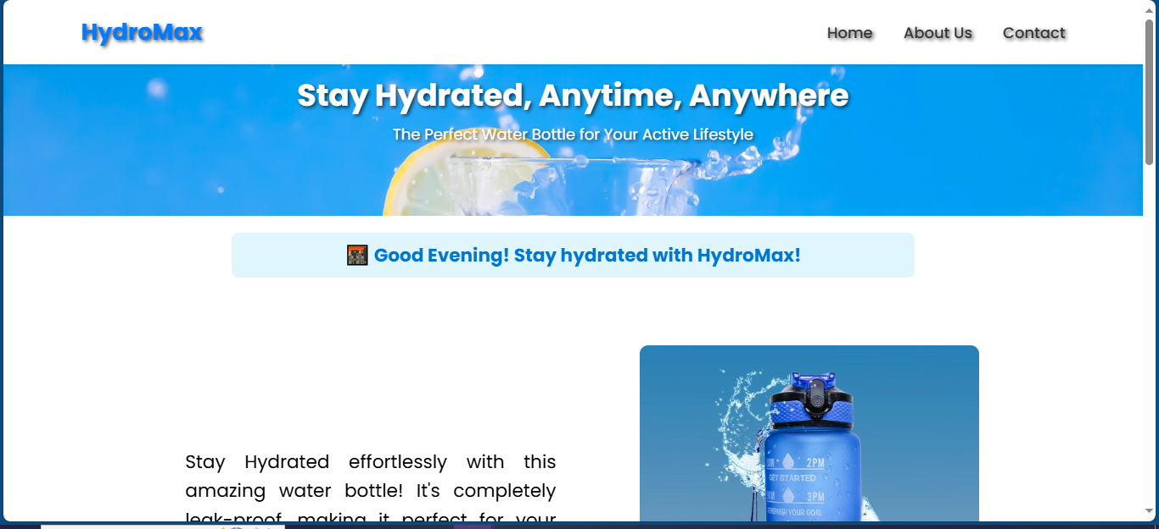
  - The calculator correctly accepts two or more numbers, processes them, and displays the sum.
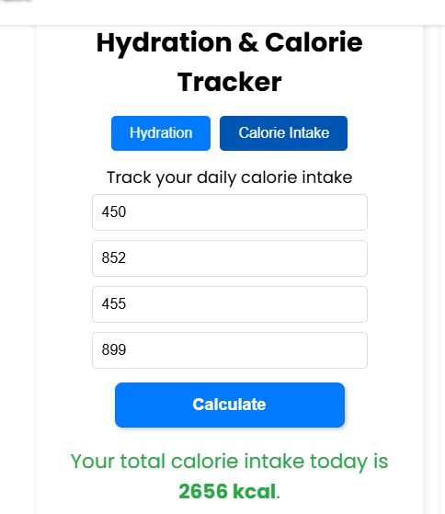

Level 2 - Task 1: Front-End Frameworks
- Objective:
  - Use a front-end framework like Bulma or UIKit to create a responsive card component with an image and text.
  - Implement a basic responsive grid layout using a front-end framework like Bootstrap or Foundation.
Implementation Details:
- The card component is designed using Bulma’s card classes for structure and styling.
- Bootstrap’s grid system ensures content is arranged responsively across different screen sizes.
- The UI elements maintain a modern, consistent look across devices.

- Output Description & Screenshot:
  - The card component displays an image with accompanying text using Bulma or UIKit.
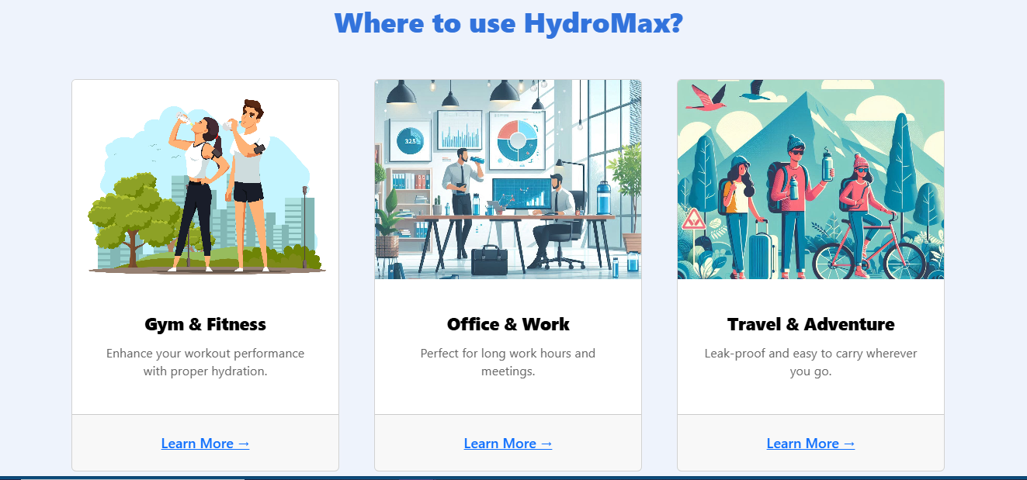
  - The responsive grid layout adapts to different screen sizes effectively.
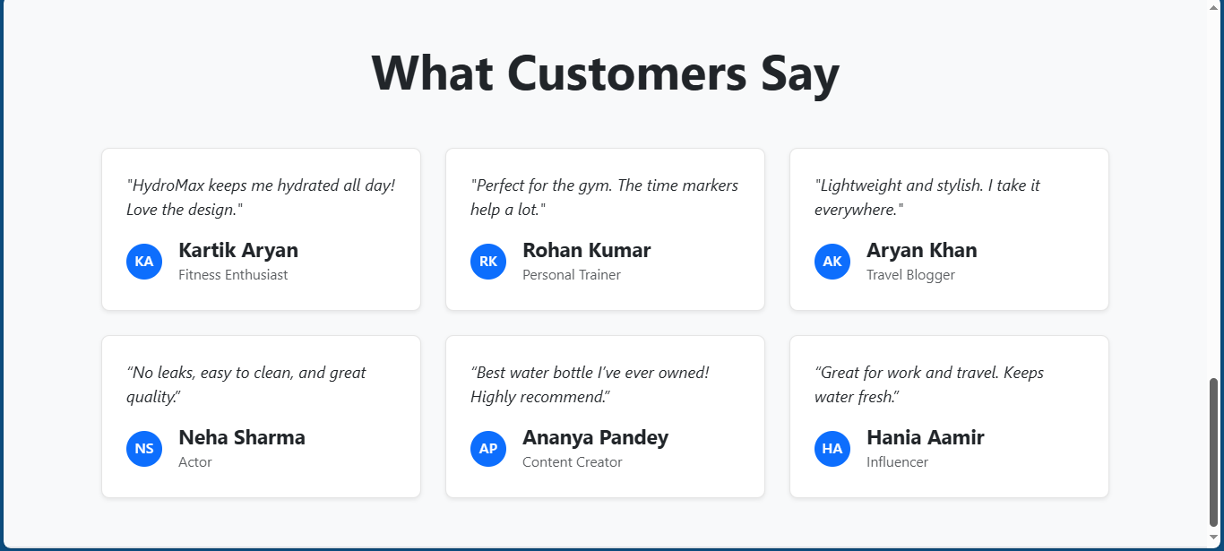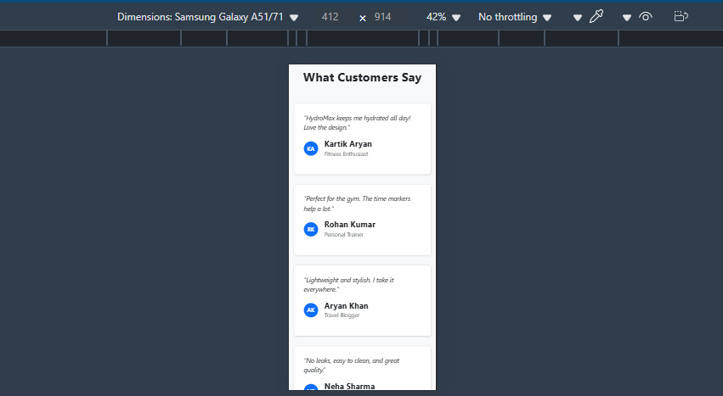
  - The design is visually engaging and functions smoothly across devices.

Level 2 - Task 2: Responsive Design
- Objective:
  - Convert a basic webpage into a responsive design that adapts to different screen sizes using CSS media queries.
  - Create a mobile-friendly navigation menu that collapses into a hamburger menu on smaller screens using HTML and CSS.
Implementation Details:
- CSS media queries adjust layouts for various screen sizes.
- The JavaScript-powered hamburger menu enhances mobile usability.
- The design ensures smooth transitions and accessibility.

- Output Description & Screenshot:
  - The webpage adjusts perfectly across various devices and screen sizes.
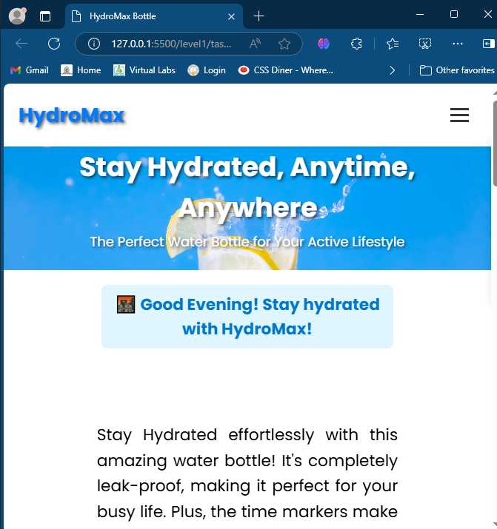

  - The navigation menu transforms into a hamburger menu on smaller screens.
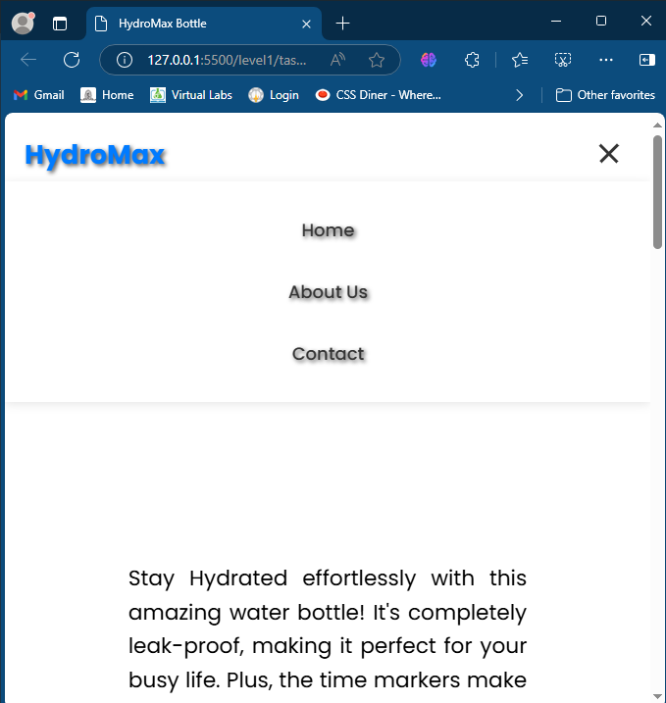
  - The design maintains a user-friendly interface, ensuring accessibility and smooth interactions.

3. Challenges and Learnings

Challenges Faced:
- Adjusting responsiveness for different screen sizes.
- Styling form elements for a better user experience.
- Implementing JavaScript functionalities correctly within HTML structures.

Learnings:
- Improved understanding of CSS Flexbox and media queries.
- Gained hands-on experience in frontend design principles.
- Learned how Bulma and Bootstrap simplify UI development.
- Understood JavaScript event listeners for interactivity.

4. Conclusion
This internship allowed me to apply my HTML, CSS, and JavaScript skills in real-world tasks. It improved my understanding of frontend development, and I look forward to applying these learnings in future projects.

5. Attachments
- ZIP folder containing all source code and output files.

This document serves as proof of work for the completion of Level 1 and Level 2 tasks in the internship program.

